**Mobile App Assignment-2**

**Rohith Kumar Manduva**

**Karthik Gundlapalli**

**Speech to Text:** We have developed an app which converts the given speech in to text and displays it. In this app we have given the permissions in the manifest file so that we can access to the systems speech detecting sensor

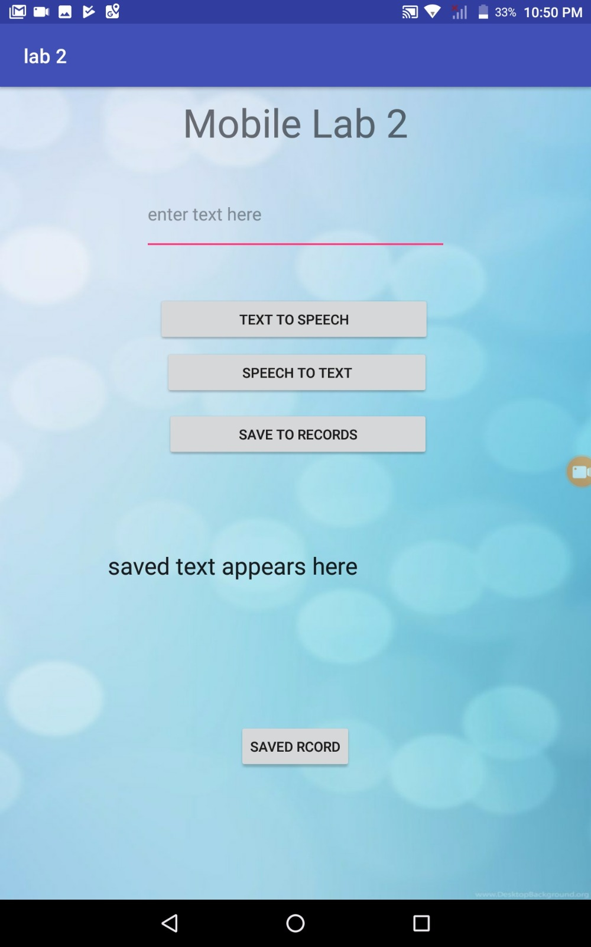

So in this app first we will speak a word or a sentence in the mic it detects your voice and converts the given voice message in to text.

Also we have used SQLite to store the data so the converted text message is stored in the records then when we hit the saved records button it will displays the latest record that we have saved earlier

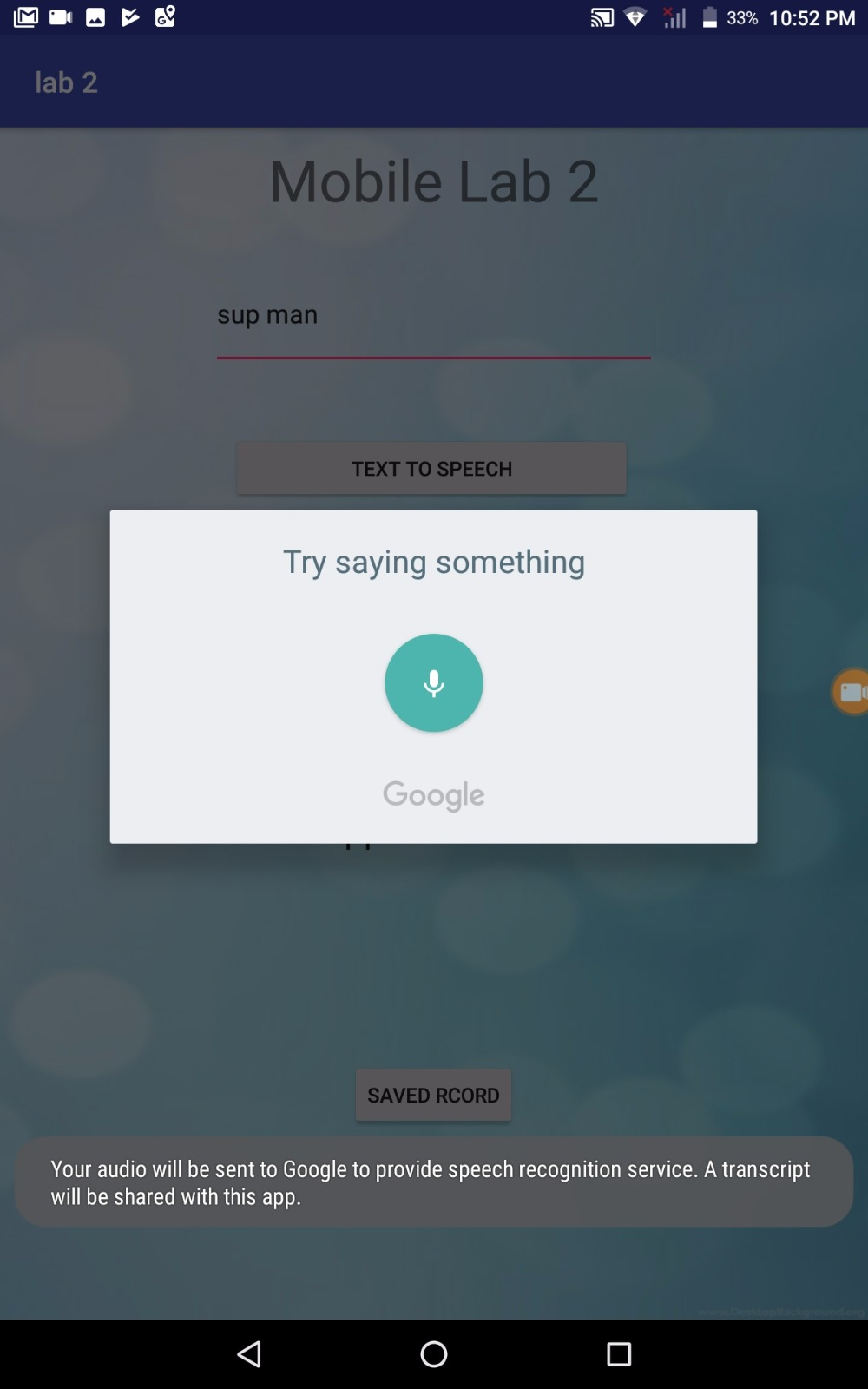

**Text to speech:** For the text to speech also we have given the permissions in the manifest file so that we can use the feature in android which converts that given text into speech. For that when we type some message in the text editor above and hit the button it converts given text into speech then we can hear our message.

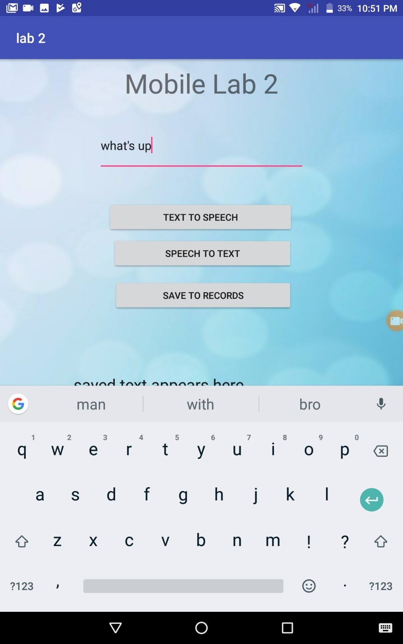

**Saved Record:** For this we have used the SQLite queries so that the we can save whatever record we want to save to the database and then when we hit the saved records it displays latest record that we have saved earlier.

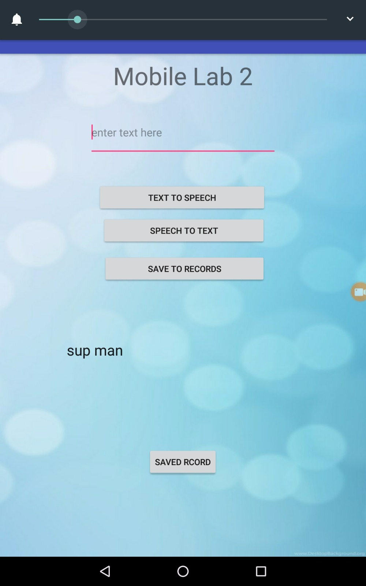

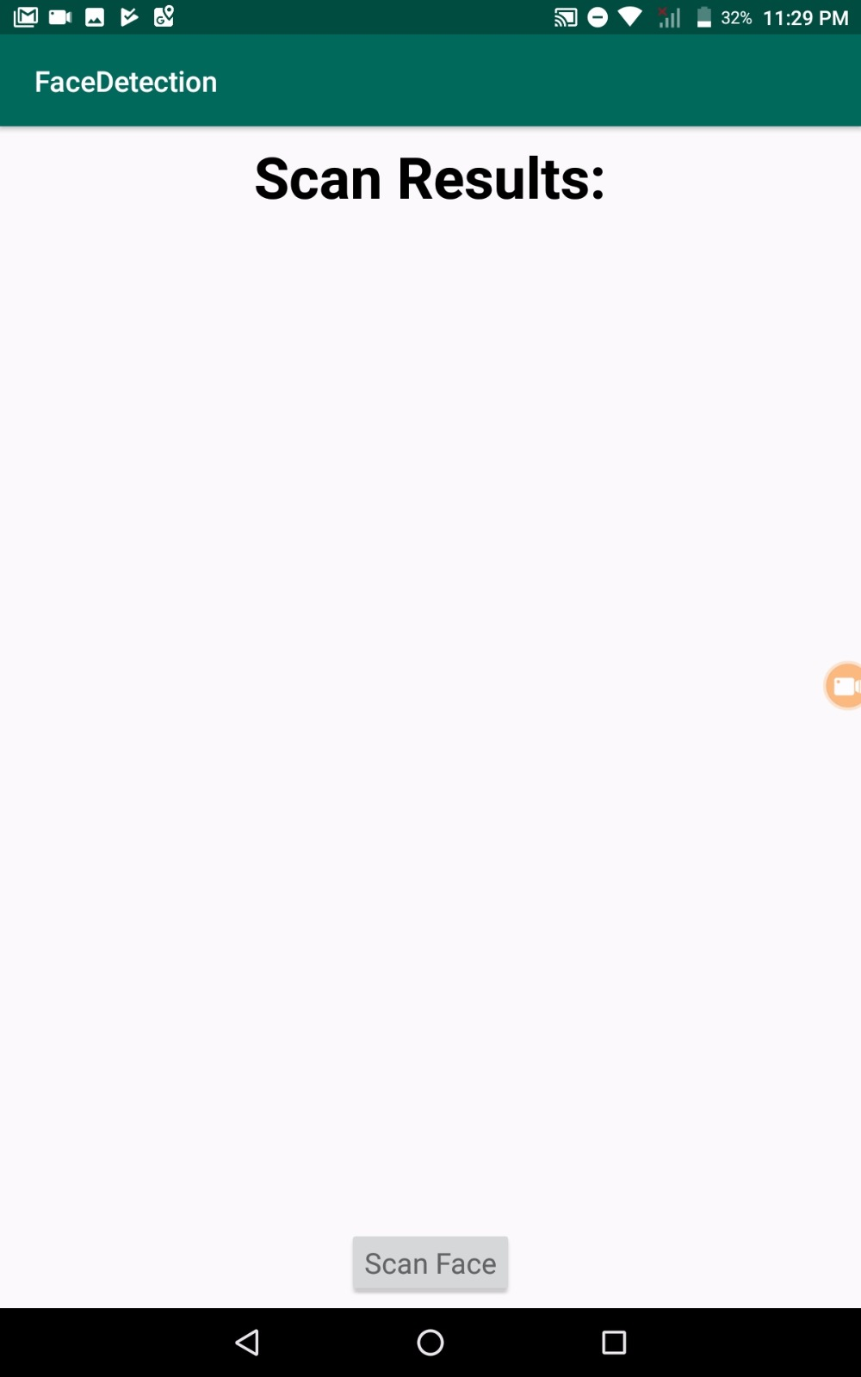

**Use of sensor:** For this we have used a machine learning API so that it uses the sensors in our phone and performs particular tasks. In the app that we have created we made the use of camera to read facial expression

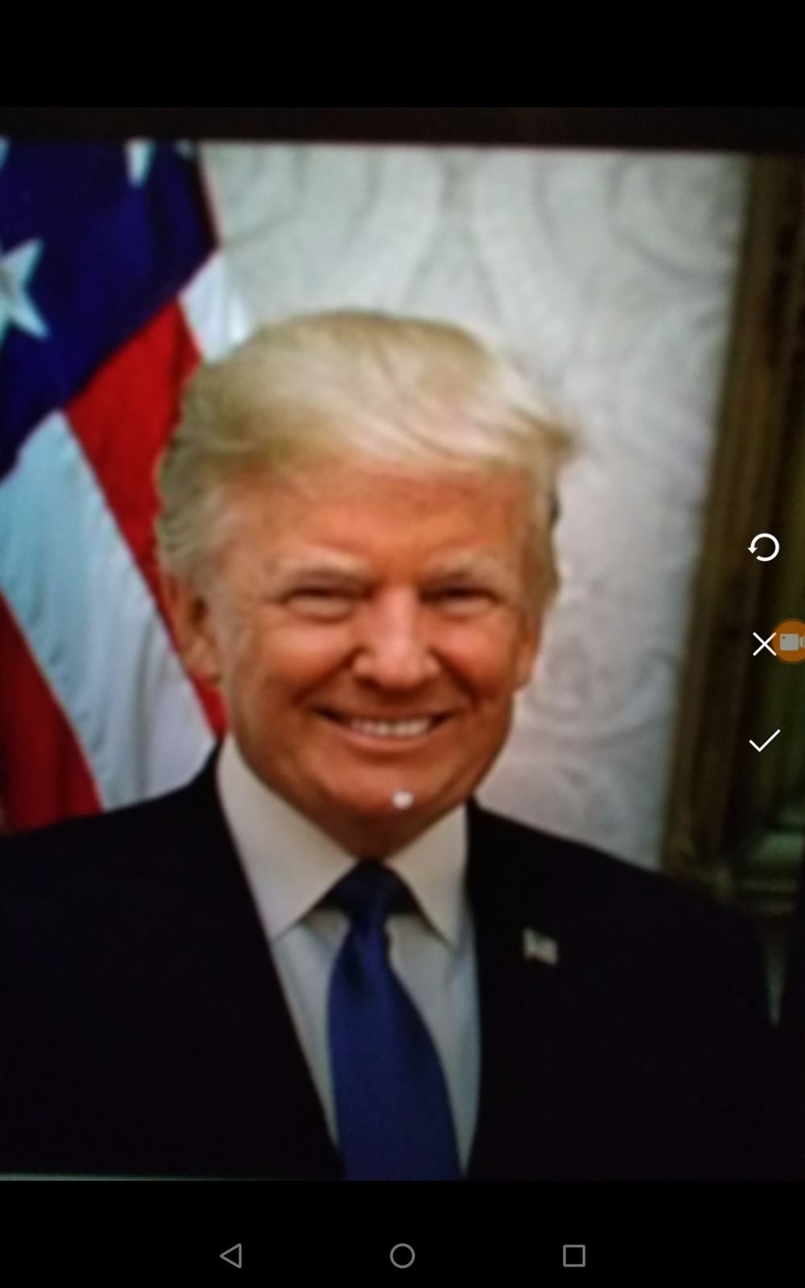

so we go to the app and we can access the camera through the app and in that we will take a picture of a particular person in that app.

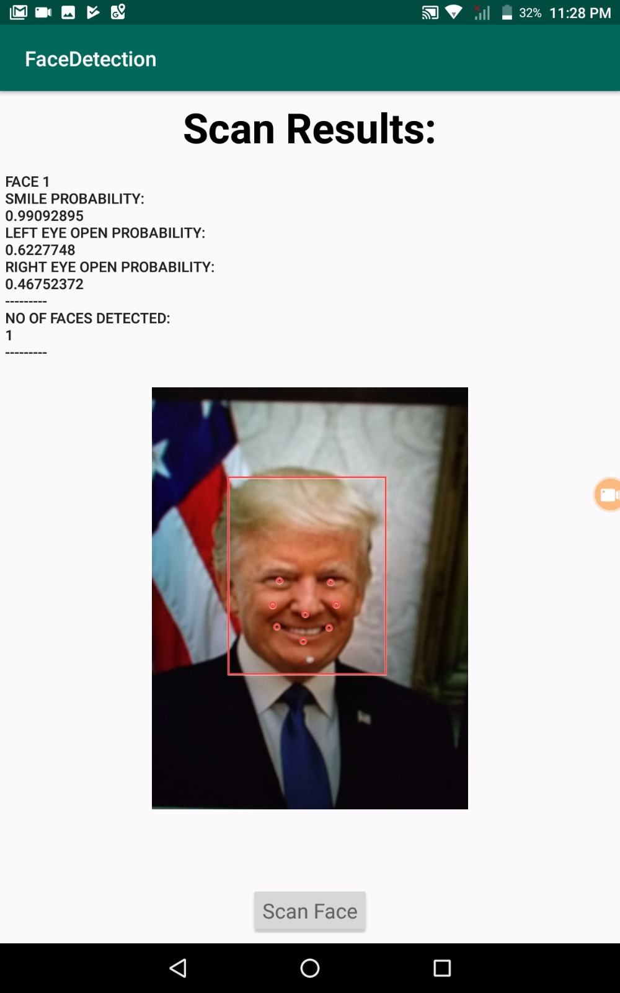

When we take a picture of a person it shows details like smile probability and some other parameters of that captured face using machine learning.